
General Chemistry I (Casanova)
Assignment 7: Chapters 7 & 8
Name: _____________________________________________ M/W or T/R ?
1. Define the following terms:

a) Ionic bonding –

b) Covalent bonding –

c) Octet rule –

d) Electronegativity –

e) Bonding (shared) pair –

f) Lone (unshared) pair –

g) Bond order –

h) Single covalent bond –

i) Double covalent bond –

j) Triple covalent bond –

k) Bond energy –
l) Bond length –

m) Polar covalent bond –

n) Nonpolar covalent bond –

o) Lewis structure –

r) Isoelectronic –

Setup of each problem must be shown when performing ANY CALCULATION from this point on. Attention should be given to significant figures.

2. Complete the following statement. (terms may be used more than once)
Atoms typically bond in order to fulfill the___________rule. When this rule is fulfilled the atom will become
___________________with a noble element. Atoms can fulfill this rule by either becoming oxidized or
reduced. This process leads to what is known as a(n)____________bond. Another process by which this rule
can be realized is through the sharing of valence electrons. This process leads to the formation of
a(n)_______________bond. The decision on what type of bond should be utilized is determined by comparing
the__________________ of the two atoms wishing to bond. If the___________________of the two atoms is
identical (homonuclear atoms) the type of bond that will result is a nonpolar covalent bond.
If the___________________of the two atoms is as different as the east is to the west the bond that results will
be a(n)________________bond. Polar covalent bonds result when small differences in___________________
exist between the two (2) atoms wishing to bond.

3. Explain why metal atoms typically form cations while nonmetals typically become anions.

4. Draw the Lewis Electron-Dot structures for the following elements.
Structure
- Phosphorous (P)

- Sulfur (S)

- Krypton (Kr)

- Carbon (C)

5. Explain what is occurring at each step (1 – 4) shown in the diagram.
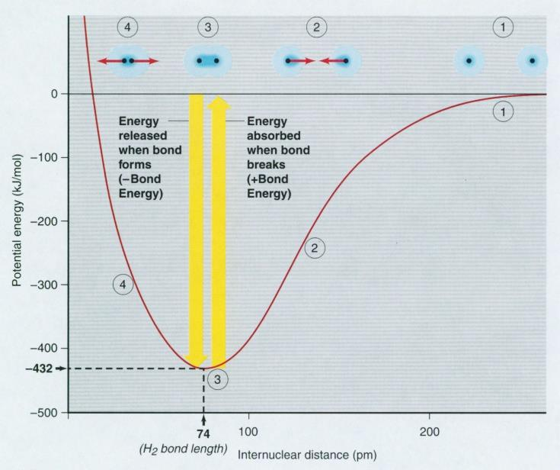
1.

2.

3.

4.

6. Explain the love-hate relationship in the formation of a covalent bond using the diagram provided.
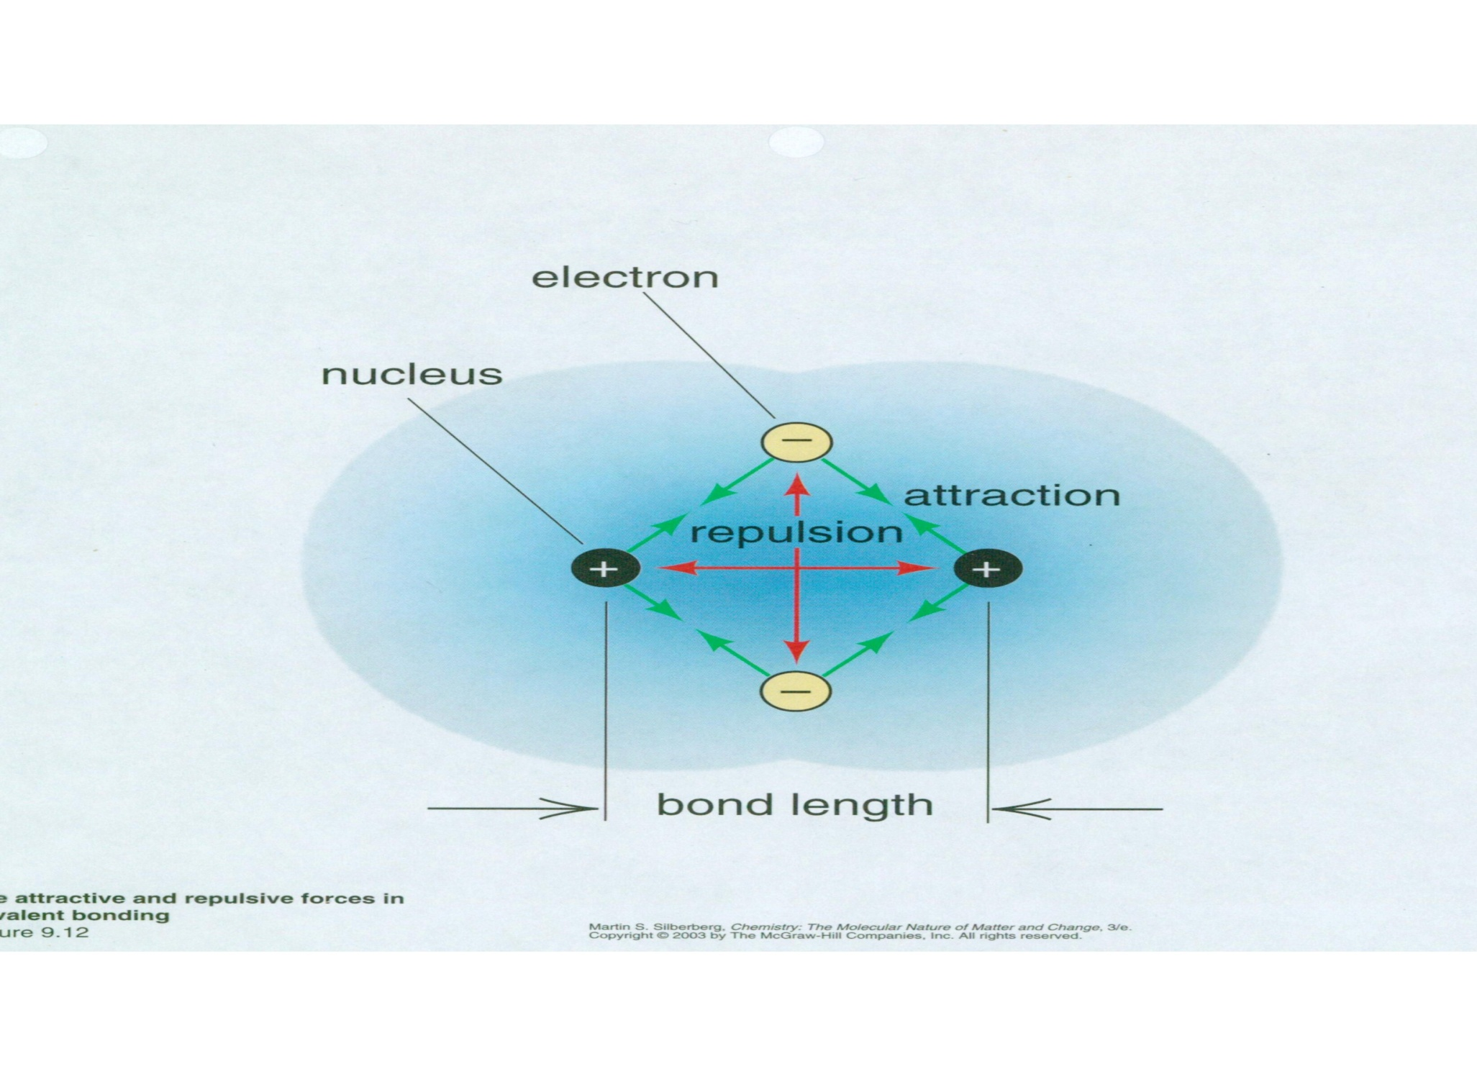
7. Explain the relationship between bond order and bond length.

8. Explain the relationship between the type of covalent bond (i.e. single, double or triple) and the bond strength.

9. Draw the Lewis Structures (as shown in class) for the following species.
 |  | Structure |  |  | Structure
- H₂S |  |  |  | g) CO₂
b) OF₂ |  |  |  | h) NO₂⁻
c) SOCl₂ |  |  |  | i) ClF₄⁺
d) NH₃O |  |  |  | j) XeF₅⁺
e) CO |  |  |  | k) BeF₂
f) HCN

10. Ozone, O₃, a major component in the upper atmosphere responsible for filtering out harmful UV radiation before it reaches the earth’s surface is a molecule that exhibits resonance. Draw all possible resonance structures (forms) for this molecule. Be sure to indicate resonance by using “” symbol between the forms.

11. The azide ion, N₃⁻, has at least two (2) plausible ways of drawing its molecular structure. Draw both structures and determine with the use of formal charge calculations which structure is most likely to occur.

12. The structure below represents a molecule of caffeine, a major component in coffee and other beverages. Determine the total number of sigma () bonds and pi () bonds found in the molecule. Remember that each –CH₃ group represents three carbon-hydrogen single bonds. (Hydrogen atoms – white; Nitrogen atoms – blue; Oxygen atoms – red; Carbon atoms – grey.)

